TCS Self Learning
JFLAP Software

1) Deterministic Finite Automata
Deterministic Finite Automaton (DFA)
A DFA is a finite state machine that accepts or rejects finite strings of symbols. Each input string produces exactly one computation, and on any finite input the DFA halts and either accepts or rejects. A DFA M recognizes the language L(M), the set of all strings M accepts.
Formal definition
A DFA is a 5-tuple (Q, Σ, δ, q₀, F), where:
- Q is a finite set of states
- Σ is a finite set of input symbols (the alphabet)
- δ: Q × Σ → Q is the transition function
- q₀ ∈ Q is the start state
- F ⊆ Q is the set of accept states
Example: This DFA over the alphabet {a, b} recognizes the language consisting of only the string “a”. It accepts “a” and rejects everything else.
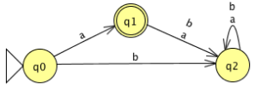
State | a | b
q₀ | q₁ | q₂
q₁ | q₂ | q₂
q₂ | q₂ | q₂
Every state has exactly one transition for each symbol of the alphabet. Because the next state is uniquely determined, the automaton is deterministic.

Example:
Consider the regular language L over the alphabet { a, b, c } comprised of all strings that begin and end
with c. Let’s construct a DFA M to recognize that language.
Some strings in the language include: c, cc, ccc, cac, cabc, cabcbabc
Some strings not in the language include: λ, a, ac, cb, ccca

Execution:
Step 1: Create initial state q0
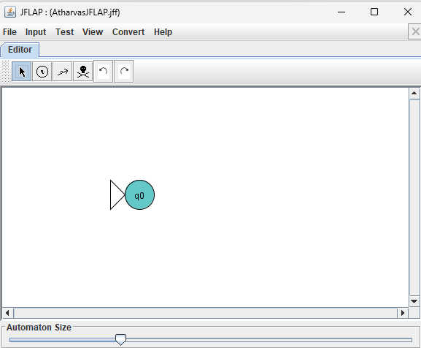
Step 2: Create a new state, q1, as the destination of a or b from q0 and which traps all subsequent
substrings
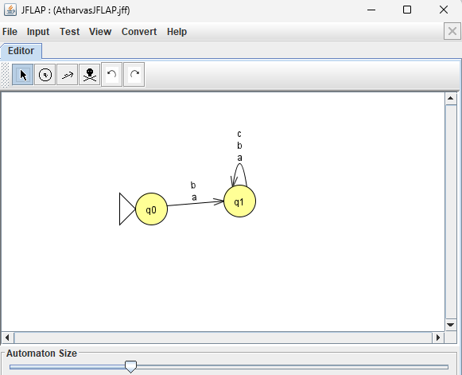

Step 3: Create a new state, q2, as the destination of transition c from q0 and which is an accept
state
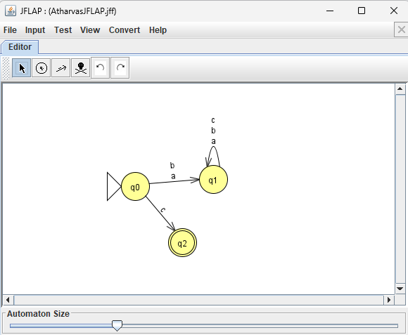
Step 4: Add a c transition to and from q2
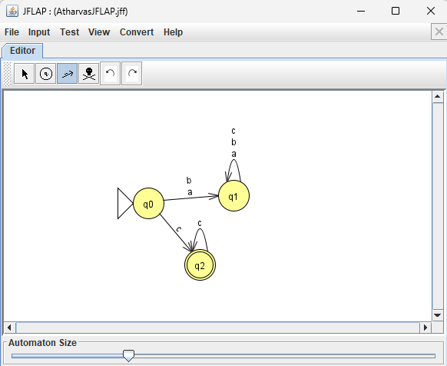

Step 5: Add state q3 with a transition of a or b from q2. Add transitions to remain in q3 for a or b.
Add transition from q3 back to q2 for c
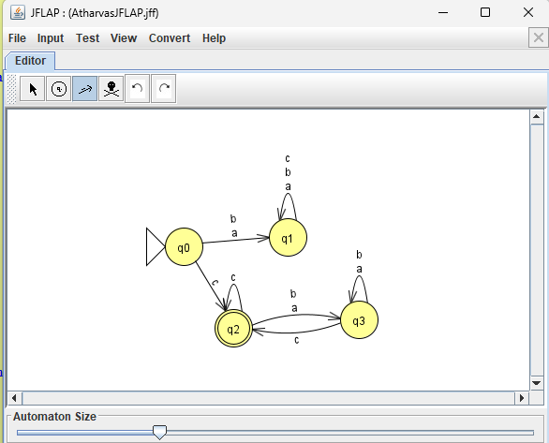

Testing with inputs:
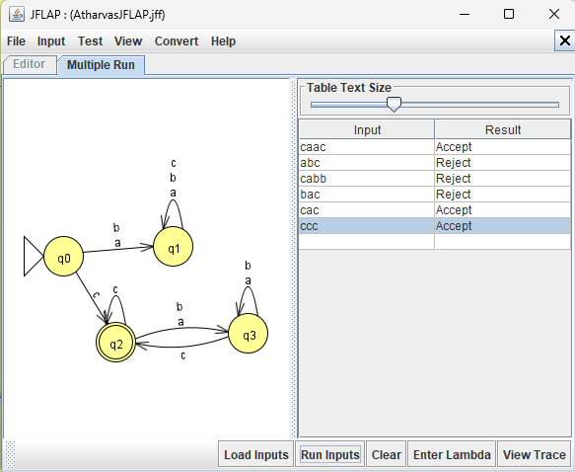
Therefore the DFA accepts all strings that start and end with c

2) Non Deterministic Finite Automata
An NFA is a finite state machine that accepts or rejects finite strings of symbols, like a DFA, but its computation on an input need not be unique. From a given state on a given symbol, it may have several possible next states, or none. An NFA N recognizes the language L(N), the set of all strings for which at least one computation path ends in an accept state.
Example: This NFA over {a, b} recognizes the strings that end in “ab”. In q₀ it keeps reading and, whenever it sees an a, can guess that this a is the second-to-last symbol and move to q₁. It then needs a b to reach q₂, and any further symbol kills that path.
Formal definition
An NFA is a 5-tuple (Q, Σ, δ, q₀, F), where:
- Q is a finite set of states
- Σ is a finite set of input symbols (the alphabet)
- δ: Q × (Σ ∪ {ε}) → P(Q) is the transition function, which returns a set of states (possibly empty)
- q₀ ∈ Q is the start state
- F ⊆ Q is the set of accept states
Example:
Define an NFA that recognizes the following language L over Σ = {a, b}:
L = { w | w ends with aa }.

Execution:
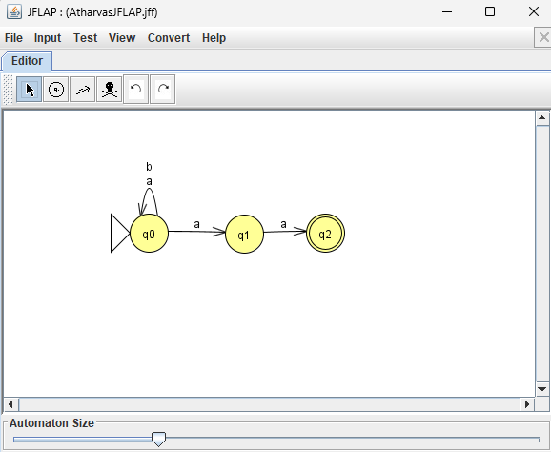

Testing:
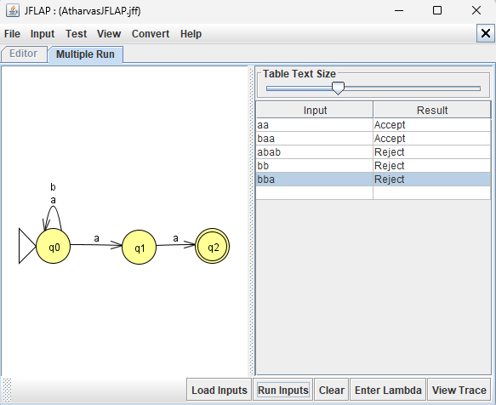
Therefore, this NFA successfully accepts all strings ending with aa.

3) NFA to DFA Conversion
Every NFA has an equivalent DFA that recognizes the same language. The subset construction builds it by making each DFA state a set of NFA states, so the DFA tracks every state the NFA could be in after reading the input so far.
Construction
Given an NFA N = (Q, Σ, δ, q₀, F), build a DFA D = (Q′, Σ, δ′, q₀′, F′), where:
- Q′ = P(Q): each DFA state is a subset of NFA states
- q₀′ = {q₀}: the start state is the set containing only the NFA’s start state
- δ′(S, a) = ⋃ δ(q, a) for q ∈ S: on symbol a, move to the union of all states reachable from any state in S
- F′ = {S ∈ Q′ | S ∩ F ≠ ∅}: a DFA state accepts if it contains at least one NFA accept state
If the NFA has ε-transitions, take the ε-closure (all states reachable by ε-moves alone) of the start state and of every result of δ′.
Procedure
- Start with the DFA state {q₀} (or its ε-closure).
- For each new DFA state S and each symbol a, compute δ′(S, a) as the union of the NFA transitions.
- If the result is a new subset, add it as a state.
- Repeat until no new subsets appear.
- Mark every subset containing an NFA accept state as accepting.
Only subsets reachable from the start are needed, so the DFA is usually much smaller than the full 2ⁿ.
Example
Convert the NFA from before (strings over {a, b} ending in “ab”, start q₀, accept q₂):
State | a | b
q₀ | {q₀, q₁} | {q₀}
q₁ | ∅ | {q₂}
q₂ | ∅ | ∅
Starting from {q₀}:
- {q₀} on a → {q₀, q₁}; on b → {q₀}
- {q₀, q₁} on a → {q₀, q₁} ∪ ∅ = {q₀, q₁}; on b → {q₀} ∪ {q₂} = {q₀, q₂}
- {q₀, q₂} on a → {q₀, q₁} ∪ ∅ = {q₀, q₁}; on b → {q₀} ∪ ∅ = {q₀}
No new subsets appear, so the DFA has three states. Naming A = {q₀}, B = {q₀, q₁}, and C = {q₀, q₂}, the DFA is ({A, B, C}, {a, b}, δ′, A, {C}), with δ′ given by:
State | a | b
A | B | A
B | B | C
C | B | A
C is the only accepting state, since it is the only subset containing q₂. The other five subsets (∅, {q₁}, {q₂}, {q₁, q₂}, {q₀, q₁, q₂}) are unreachable, so they are left out.
Key points
- The construction proves NFAs and DFAs recognize exactly the same languages, the regular languages.
- The DFA can need up to 2ⁿ states for an n-state NFA, and some languages really do require this blowup.
- The empty set ∅ acts as the DFA’s “dead” state when it is reachable.

Example:
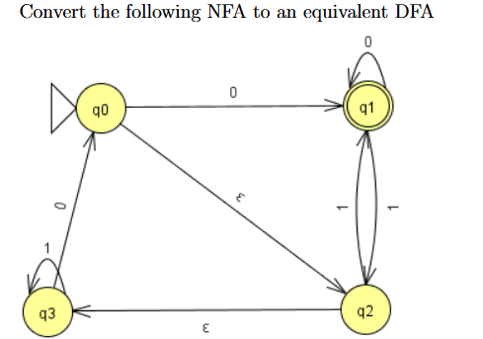

Final DFA
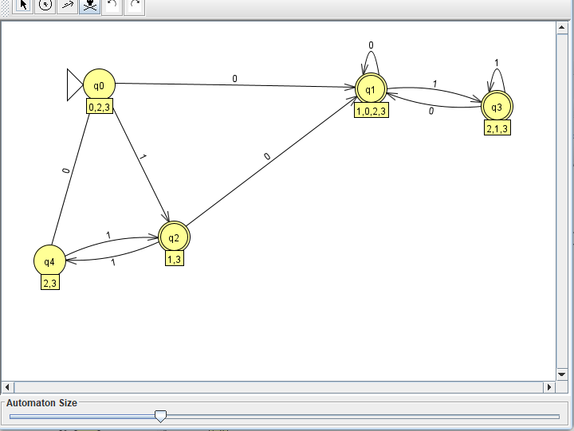

4) DFA Minimization
Different DFAs can recognize the same language, but every regular language has a unique minimal DFA: the one with the fewest states, unique up to renaming. Minimization finds it by removing unreachable states and merging states that behave identically.
Key idea
Two states p and q are equivalent if, for every string w, starting from p and starting from q lead to the same accept/reject outcome. Equivalent states can be merged without changing the language. If some string w gives different outcomes, the states are distinguishable.
Procedure (partition refinement)
- Remove unreachable states. Delete any state that can’t be reached from q₀.
- Split by acceptance. Start with two groups: accepting states F and non-accepting states Q \ F.
- Refine. Split a group if two of its states send some symbol a to different groups. Repeat until no group splits.
- Merge. Each final group becomes one state of the minimal DFA. The start state is the group containing q₀, the accept states are the groups inside F, and transitions follow the group of the target.
Equivalently, the table-filling method marks pairs of states as distinguishable, starting with (accepting, non-accepting) pairs, then marking any pair that moves to an already marked pair on some symbol. Unmarked pairs at the end are equivalent.
Example
Take this DFA over {a, b} with start state 0 and F = {2, 3}:
State | a | b
0 | 1 | 2
1 | 1 | 3
2 | 1 | 3
3 | 1 | 2
4 | 0 | 4
- Step 1: State 4 is unreachable, so remove it.
- Step 2: The groups are {0, 1} (non-accepting) and {2, 3} (accepting).
- Step 3: In {0, 1}, on a both states go to 1 (same group), and on b they go to 2 and 3 (same group). In {2, 3}, on a both go to 1, and on b they go to 3 and 2 (same group). Nothing splits, so the partition is final.
- Step 4: Merge into P = {0, 1} and Q = {2, 3}.
The minimal DFA is ({P, Q}, {a, b}, δ, P, {Q}), with δ given by:
State | a | b
P | P | Q
Q | P | Q
It recognizes the strings that end in b. Five states reduced to two.
Already minimal
The 3-state DFA from the NFA conversion (strings ending in “ab”) is already minimal. The initial groups are {A, B} and {C}. On b, A goes to A but B goes to C, so {A, B} splits, leaving three singleton groups.
Key points
- Minimization never changes the language, only the number of states.
- The minimal DFA is unique, which gives a way to test whether two DFAs are equivalent: minimize both and compare.
- This relies on the Myhill-Nerode theorem: the number of states in the minimal DFA equals the number of distinguishable classes of strings for the language.
- Hopcroft’s algorithm does the refinement in O(n log n) time for n states.

Example:
Consider the language L1 = {w ∈ Σ∗|w is λ or w ends in a}.

Execution:
DFA:
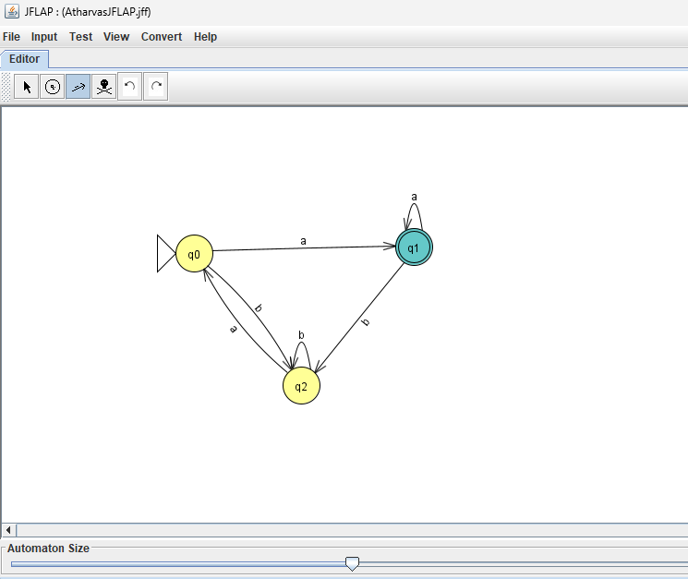

Minimized DFA:
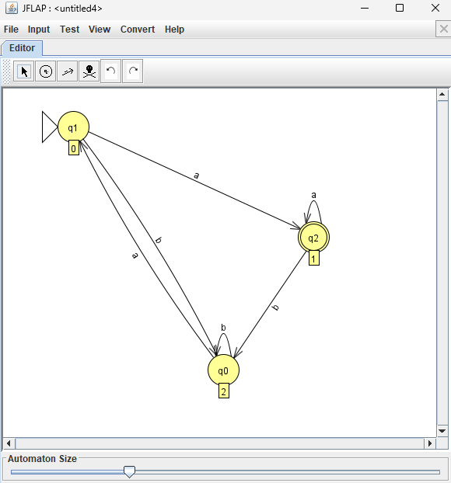

5) DFA to Regular Grammar Conversion
Every DFA can be converted into an equivalent regular grammar, a grammar that generates exactly the language the DFA recognizes. The idea is to turn each state into a non-terminal and each transition into a production, so that a derivation mirrors a run of the DFA.
Regular grammars
A right-linear grammar has productions of the form A → aB, A → a, or A → ε, where A and B are non-terminals and a is a terminal. Each rule produces at most one terminal followed by at most one non-terminal, at the right end. Right-linear grammars generate exactly the regular languages.
Construction
Given a DFA D = (Q, Σ, δ, q₀, F), build a grammar G = (V, Σ, P, S), where:
- V = Q: each state becomes a non-terminal
- S = q₀: the start state becomes the start symbol
- Transition rule: for each δ(p, a) = q, add the production p → aq
- Accept rule: for each p ∈ F, add the production p → ε
Reading a symbol corresponds to producing a terminal and moving to the next non-terminal. Reaching an accept state allows the derivation to end with ε.
Procedure
- Name a non-terminal for each state, with the start state as the start symbol.
- For every transition p —a→ q, write p → aq.
- For every accept state p, write p → ε.
- Optionally, drop any non-terminal that can never lead to a string (a dead or trap state) along with the productions that use it.
Example
Take the DFA from the NFA conversion (strings over {a, b} ending in “ab”), with start state A and accept state C:
State | a | b
A | B | A
B | B | C
C | B | A
The grammar has V = {A, B, C}, start symbol A, and these productions:
- A → aB | bA
- B → aB | bC
- C → aB | bA | ε
Derivation of “aab”: A ⇒ aB ⇒ aaB ⇒ aabC ⇒ aab
This matches the DFA’s run on “aab”: A →a→ B →a→ B →b→ C, which ends in the accept state C. A string like “aba” fails: the derivation reaches C after “ab”, but then the only way to continue is a → B, which cannot end in ε.
Example;:
Consider this DFA
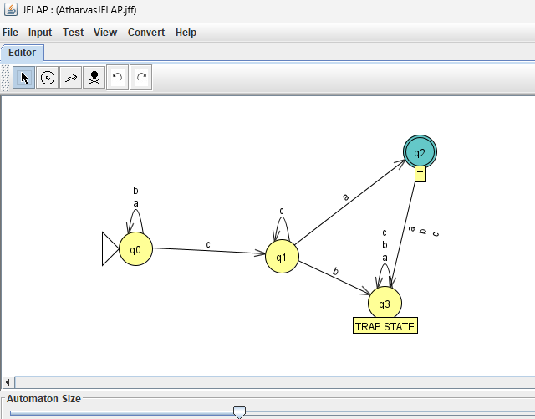
State q0 labeled R we have the following (→ is pronounced reduces to )
R → cS
R → aR
R → bR
S → aT
S → cS
T → null
Step 1:
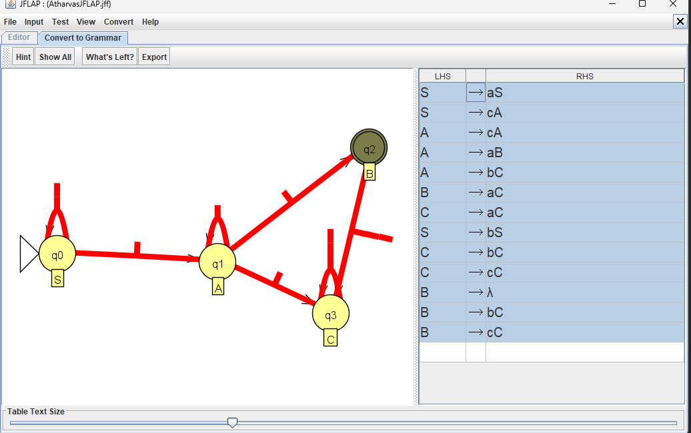

Therefore DFA has been converted to Grammer

6) DFA to Regular Expression Conversion
Every DFA can be converted into an equivalent regular expression, one that describes exactly the language the DFA recognizes. The standard method is state elimination: remove the DFA’s states one at a time, replacing transition labels with regular expressions, until a single expression remains.
Key idea
Allow edges to be labeled with regular expressions instead of single symbols. This is called a generalized NFA (GNFA). When a state is removed, every path that went through it is replaced by a direct edge whose label is the regular expression for that detour. The language does not change.
Procedure
- Add a new start state S with an ε-edge to the old start state.
- Add a new accept state F with ε-edges from every old accept state. These old states are no longer accepting.
- Merge parallel edges. If several edges go from p to q, replace them with one edge labeled by the union (R₁ | R₂ | …). If there is no edge, treat it as ∅.
- Eliminate each original state q one at a time. For every pair of states p and r with an edge into q and an edge out of q, add or extend the edge p → r with the label R_pq (R_qq)* R_qr:
  - R_pq is the label from p to q
  - R_qq is the label of the loop on q (use ε if none)
  - R_qr is the label from q to r
  - If p → r already exists, union the new label with the old one.
- Stop when only S and F remain. The label on the edge S → F is the regular expression.
Example
Take the DFA from the earlier sections (strings over {a, b} ending in “ab”), with start state A and accept state C:
State | a | b
A | B | A
B | B | C
C | B | A
After adding S and F, the edges are:
- S → A: ε
- A → A: b, A → B: a
- B → B: a, B → C: b
- C → B: a, C → A: b, C → F: ε
Eliminate A (loop b, so the middle term is b*):
- S → B: ε · b* · a = b*a
- C → B: a | (b · b* · a) = a | b⁺a = b*a
Eliminate C (no loop; the only edge in is from B on b, and the edges out are to B on b*a and to F on ε):
- B → B: a | (b · b*a) = b*a
- B → F: b
Eliminate B (loop b*a, so the middle term is (b*a)*):
- S → F: b*a · (b*a)* · b = (b*a)⁺b
The regular expression is (b*a)⁺b. It is equivalent to the more familiar (a|b)*ab, since a string ends in “ab” exactly when it is a string ending in a (that is, (b*a)⁺) followed by b.
Example
Consider the following DFA
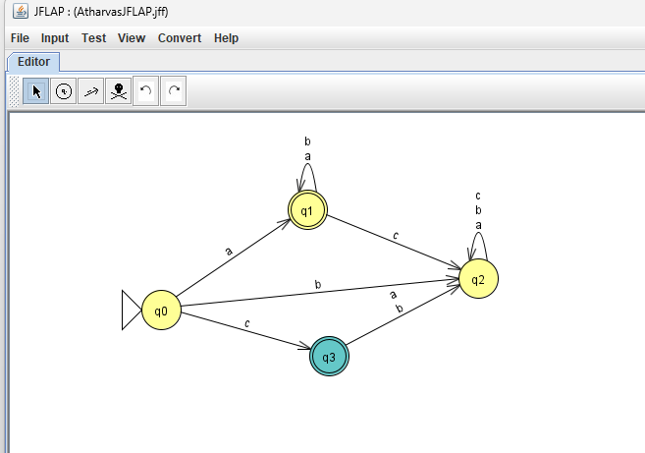

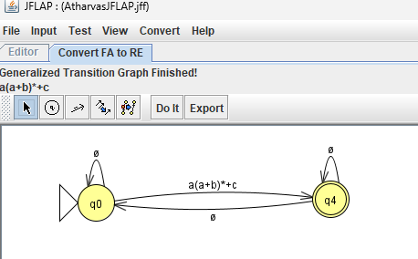
Therefore we have successfully converted DFA to RE

7) Combining Automata
Regular languages are closed under union, intersection, difference, complement, concatenation, and star. Each has a construction on finite automata.
Product construction (union, intersection, difference)
Given DFAs M₁ = (Q₁, Σ, δ₁, q₁, F₁) and M₂ = (Q₂, Σ, δ₂, q₂, F₂) over the same alphabet, run both in parallel:
- States: Q₁ × Q₂
- Start: (q₁, q₂)
- Transition: δ((p, q), a) = (δ₁(p, a), δ₂(q, a))
- Accept states:
  - Union: p ∈ F₁ or q ∈ F₂
  - Intersection: p ∈ F₁ and q ∈ F₂
  - Difference L₁ \ L₂: p ∈ F₁ and q ∉ F₂
Only accept set changes between operations.
Complement
Swap accepting and non-accepting states: F′ = Q \ F. The DFA must be complete (a transition on every symbol from every state).
ε-NFA constructions
- Union: add a new start state with ε-edges to both start states.
- Concatenation L₁L₂: add ε-edges from each accept state of M₁ to the start state of M₂. Only F₂ accepts.
- Star L*: add a new accepting start state with an ε-edge to the old start state, and ε-edges from each old accept state back to the old start state.
Example
Let M₁ accept an even number of a’s (states E, O) and M₂ accept strings ending in b (states N, Y). The product starts at (E, N):
State | a | b
(E, N) | (O, N) | (E, Y)
(E, Y) | (O, N) | (E, Y)
(O, N) | (E, N) | (O, Y)
(O, Y) | (E, N) | (O, Y)
- Intersection: accept {(E, Y)}
- Union: accept {(E, N), (E, Y), (O, Y)}
- Difference L₁ \ L₂: accept {(E, N)}
Example:
In this Exercise, we will use the “Combine Automata” feature of JFLAP to find the inter-
section of two DFA. For the alphabet Σ = {a, b}, consider the languages
L1 = {w ∈ Σ∗|w has an odd number of a’s}, and
L2 = {w ∈ Σ∗|w does not have ab as a substring}

Step 1: Load the files odd-a.jflap and no-ab.jflap in two separate windows, as below
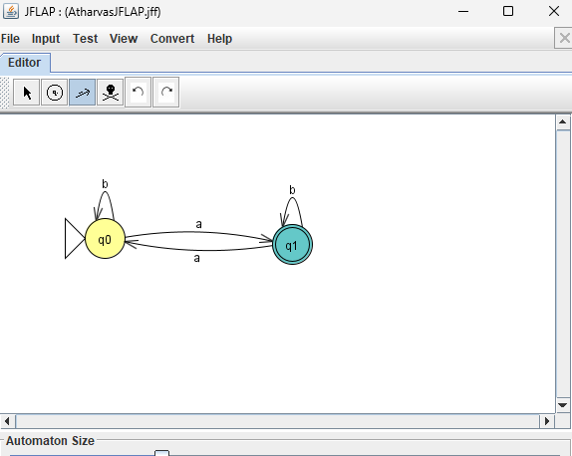
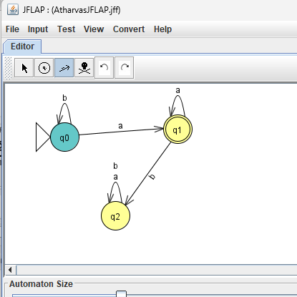

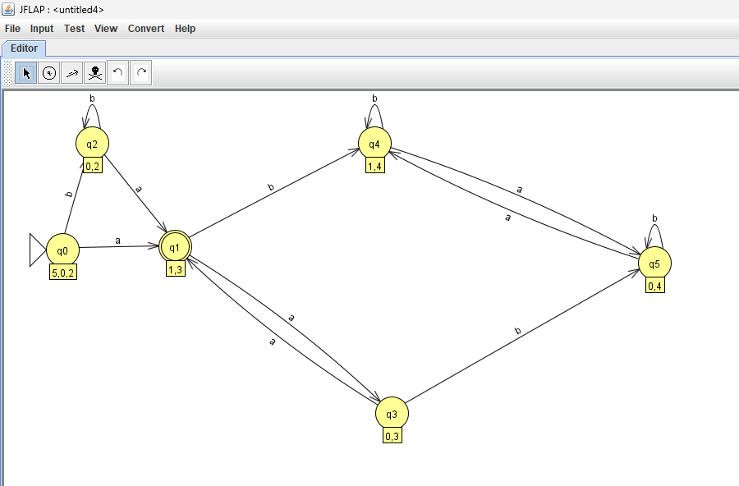
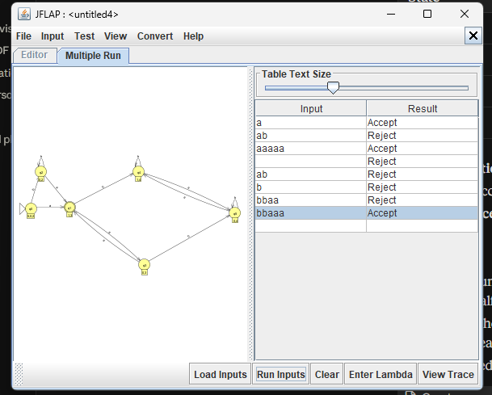
Hence this DFA accepts all strings that have odd no. of a’s and have no ab substring

8) Regular Expression to DFA conversion
Regular Expression to DFA Conversion
Build an ε-NFA from the expression (Thompson’s construction), then convert it to a DFA (subset construction). Minimizing afterwards is optional.
Step 1: Thompson’s construction
Each piece has one start state and one accept state:
- a (a symbol): start —a→ accept
- R | S: a new start with ε-edges to the starts of R and S, and ε-edges from their accept states to a new accept state
- RS: an ε-edge from R’s accept state to S’s start
- R*: a new start and a new accept state. The new start has ε-edges to R’s start and to the new accept. R’s accept has ε-edges back to R’s start and to the new accept.
Step 2: Subset construction
- The start state is the ε-closure of the NFA’s start state (all states reachable by ε-moves alone).
- For each DFA state S and symbol a, compute ε-closure(move(S, a)).
- Repeat until no new sets appear.
- A set is accepted if it contains the NFA’s accept state.
Example: (a|b)*ab
The Thompson NFA gives four DFA states:
- A = ε-closure of the start state
- B = the state reached after reading an a (the NFA is now ready to read b)
- C = the state reached after reading “ab” (contains the NFA accept state)
- D = the state reached after reading a b from A, B-less (same behavior as A)
State | a | b
A | B | D
B | B | C
C | B | D
D | B | D
C is the only accepting state. A and D have identical rows, so minimization merges them:
State | a | b
A | B | A
B | B | C
C | B | A
This is the 3-state DFA for strings ending in “ab” from the earlier sections.
Example: Convert the following Regular Expression to a DFA aba ∪ ba∗
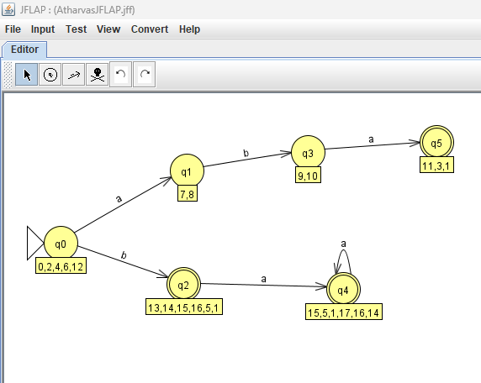

9) Mealy Machine
A Mealy machine is a finite automaton that produces output. Instead of accepting or rejecting, it writes an output symbol on every transition, so the output depends on the current state and the input symbol.
Formal definition
A Mealy machine is a 6-tuple (Q, Σ, Δ, δ, λ, q₀), where:
- Q is a finite set of states
- Σ is the input alphabet
- Δ is the output alphabet
- δ: Q × Σ → Q is the transition function
- λ: Q × Σ → Δ is the output function
- q₀ is the start state
There are no accepted states. The output has the same length as the input.
Example: detect “ab”
Over {a, b}, output 1 whenever the symbol just read completes “ab”, and 0 otherwise. The states are A (last symbol was not a) and B (last symbol was a). Each cell shows next state / output:
State | a | b
A (start) | B / 0 | A / 0
B | B / 0 | A / 1
On input “aab”: A —a/0→ B —a/0→ B —b/1→ A, so the output is 001.
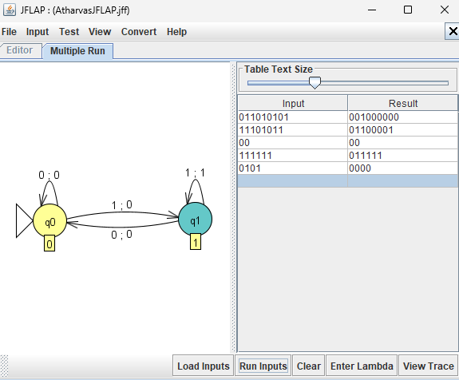
Example:
Construct a Mealy machine which takes a binary number and replaces the first 1 with a 0 from
every substring starting with 1. For example, 0001001110 becomes 0000000110. This type of
“bit stuffing” may be used in data transmission and telecommunications for run-­‐length coding to
limit the number of consecutive bits of the same value. A bit of the opposite value is inserted
after the maximum allowed number of consecutive bit

10) Moore Machine
A Moore machine is a finite automaton that produces output, where the output depends only on the current state. Each state carries an output symbol, which is written whenever the machine enters that state.
Formal definition
A Moore machine is a 6-tuple (Q, Σ, Δ, δ, λ, q₀), where:
- Q is a finite set of states
- Σ is the input alphabet
- Δ is the output alphabet
- δ: Q × Σ → Q is the transition function
- λ: Q → Δ is the output function, defined on states
- q₀ is the start state
There are no accepted states. The output has length |input| + 1, since the start state also produces an output before any symbol is read.
Example: detect “ab”
Over {a, b}, output 1 when the last two symbols read are “ab”, and 0 otherwise. The states are A (last symbol was not a), B (last symbol was a), and C (just completed “ab”). Each state has an output, and each cell shows the next state:
State | Output | a | b
A (start) | 0 | B | A
B | 0 | B | C
C | 1 | B | A
On input “aab”: A —a→ B —a→ B —b→ C, so the outputs are 0, 0, 0, 1, giving 0001. The first 0 comes from the start state. Dropping it gives 001, the same as the Mealy machine.
Example:
Construct a Moore machine which takes a binary number and replaces the first 1 with a 0 from
every substring starting with 1. For example, 0001001110 becomes 0000000110. This type of
“bit stuffing” may be used in data transmission and telecommunications for run-­‐length coding to
limit the number of consecutive bits of the same value. A bit of the opposite value is inserted
after the maximum allowed number of consecutive bits.

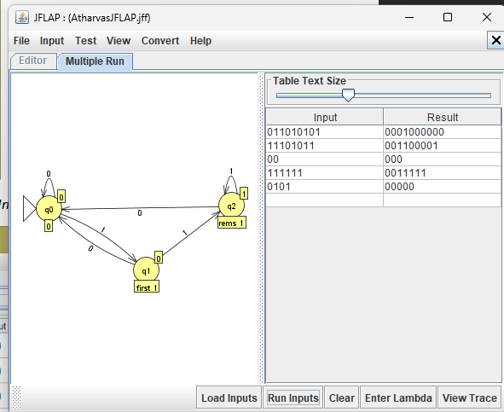

Conclusion
Thus, the experiments were successfully performed using JFLAP software to understand and implement different concepts of automata theory. The experiments demonstrated the construction and testing of Deterministic Finite Automata (DFA) and Non-Deterministic Finite Automata (NFA), conversion of NFA to DFA, DFA minimization, conversion of DFA into regular grammars and regular expressions, and the combination of automata to perform language operations. The conversion of regular expressions into finite automata was also explored. Additionally, Mealy and Moore machines were implemented to understand how finite-state machines generate outputs based on transitions and states, respectively. Overall, these experiments provided practical knowledge of finite-state machines, regular languages, and their applications using JFLAP.

